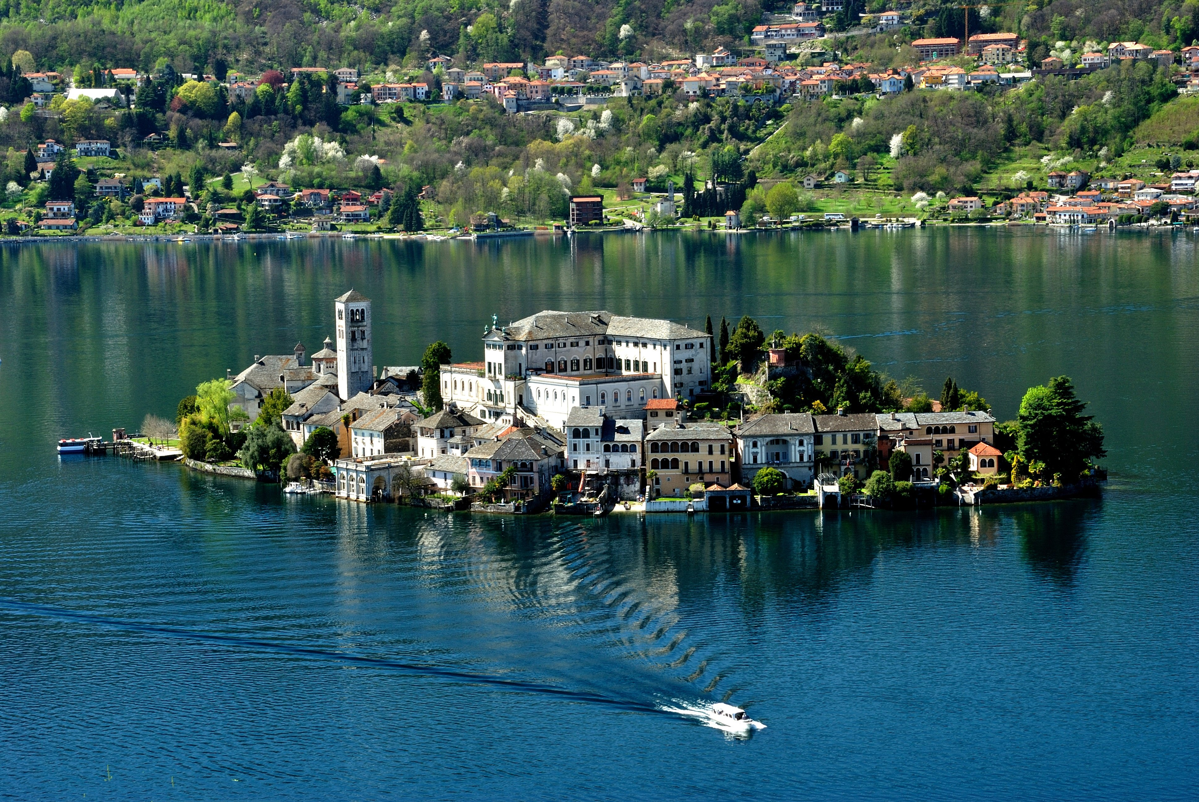

**Hardy Plant Society / Mid-Atlantic Group**

**Gardens of the Northern Italian Lakes**

 

**Hardy Plant Society / Mid-Atlantic Group**

**12 – 22 September 2016**

**£2155.00pp ($3300 approximately) double occupancy; single supplement £475**

The fabulous scenery and benign climate of the north Italian lakes have attracted the aristocrats and wealthy citizens of Italy for centuries and today their elegant villas and lush gardens complement the natural landscape perfectly. Our three-centered holiday will tour the stunning lakes of **Lake Como, Lake Garda,** and **Lake Maggiore** where we will explore a succession of villas and their gardens, bursting with colour and fragrance, all set against a breathtaking backdrop of snow-capped mountains and glittering water.

Perhaps nowhere captures the extravagant spirit of the lake-land gardens better than those around the Borromean islands on Lake Maggiore. **Isola Bella** is home to a vast baroque palace built from the island’s rock and surrounded by terraced gardens that were inspired by the ‘Hanging Gardens of Babylon’ and were once the scene of sumptuous and lavish parties, attended by the cream of European nobility. In contrast, **Isola Madre** has a simple, unspoilt aspect, where tropical and Mediterranean plants flourish and woods of native trees allow for shaded and fragrant walks, while the botanical garden of **Villa Taranto** is often described as “living encyclopedia of horticulture”.

We are delighted to introduce to the Hardy Plant Society / Mid-Atlantic Group the services of Kate Williamson, who will escort the group throughout the entire time spent in Italy. Kate was born and educated to University level in Britain and is a long-term local resident of the Northern Italian Lake area. She has built a solid reputation for herself in education and cultural tourism and has collaborated with renowned Italian horticulturalist **Gianfranco Giustina,**translating for him on RHS projects and other garden group visits. Recently, she has been collaborating with the local Chamber of Commerce for the promotion of the ‘Horticultural District of Lake Maggiore’ and for the ‘Association for the Promotion of Ornamental Building Stone’. She has a level-one Sommelier qualification and is often involved in team-building and local food and wine presentations in the Michelin starred hotels of the area.

Kate’ s local knowledge will be a great asset to our holiday.

**Itinerary**

**Monday 12 September 2016**

On arrival in Milan we will be met by our tour leader Kate Williamson and transferred to the **Hotel Barchetta Excelsior**, Como. All rooms have a lake view overlooking Lake Como.

A welcome drink will be served, followed by dinner in the hotel.

**Tuesday 13 September 2016**

This morning following breakfast, we depart on a short drive along the western shore to **Villa Carlotta**, taking time to enjoy the vast botanical garden and neoclassical art in the elegant 17th-century villa. The original formal Italian garden was later redeveloped as a more natural English-style landscaped park and more recent times has seen the addition of a Japanese bamboo garden. The verdant green “Valley” or dell is beautiful with its mottled patches of sunshine and shadow.

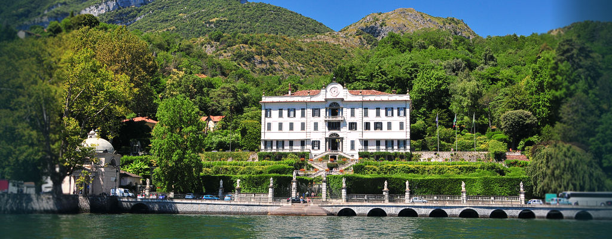

Villa Carlotta Photo ©Brightwater Holidays

**Tuesday 13 September 2016 (continued)**

Later we transfer by boat across the lake to Bellagio to visit the serene, elegant **Villa Melzi** park (the house is still private property and not open to the public). This is the very first example of an English romantic garden in Italy, laid out from 1810 by Luigi Canonica and the agronomist Luigi Villoresi. The limited space is cleverly expanded and the pollarded plane trees, the careful panting of acers and other handsome species suggest broad vistas that lead the eye both towards the lake and up to the restrained beauty of the neoclassical villa.

Dinner will be served in the hotel.

**Wednesday 14 September 2016**

Today we have the chance to view the garden of one of the most exclusive hotels in Europe, the five-star **Hotel Villa d’Este** at Cernobbio. Its Renaissance garden dates from the 16th century, and the nymphaeum adds to the scenic splendour whilst in the lower garden, wide lawns are delimited by boxwood hedges. In 2004 the Chef’s Garden was created following the scheme of the ancient “Jardin Potager”.

Later in the day we will drive up to Lenno to take a small motor-launch to the enchanting setting of the Lavedo Point for a guided visit to **Villa del Balbianello**, now in the hands of FAI (Fondo Ambiente italiano, the Italian National Trust). The villa has changed hands many times and our guided visit will reveal its character as well as the personality of its last owner, the explorer Guido Monzino. After the guided visit we have a little free time to soak up the atmosphere and lyricism of the unique garden with its famous canopy-cut Holm oak. This villa features prominently in the closing scenes of the James Bond movie ‘Casino Royale’.

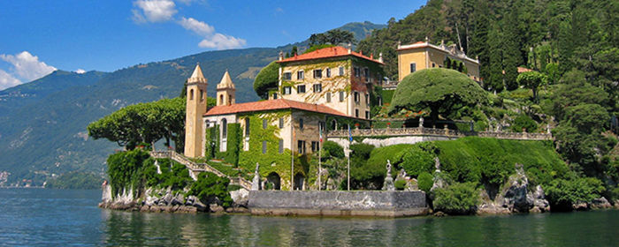

Villa del Balbianello Photo ©Brightwater Holidays

Evening at leisure.

**Thursday 15 September 2016**

We check out of our hotel and start our drive towards the biggest of the Italian pre-alpine lakes, **Lake Garda.** Along the way we stop for a morning visit to the **Fondazione Minoprio** **park** at Vertemate, Como. The foundation is based at Villa Raimondi, built in the 18th century, and is a specialist Horticultural School and Research Centre with many interests, working in collaboration with the Region of Lombardy and the Italian Ministry for Food, Forestry and Agricultural Policies. Visits are by special arrangement only, and we will be accompanied around the park, orchard of rare fruits (100 varieties of fruit trees and 30 soft fruit types), and greenhouses. There is even a pumpkin greenhouse in autumn. The botanical garden, near the Seveso river, has 300 main tree species and about 1,600 shrubs and small trees in a 7 hectare garden. The level of preparation of the students of the Floro Orto Frutticoltura School is well appreciated by the visitor who cannot help but love this natural archive open to plant lovers.

Then we drive on towards **Lake Garda** to our accommodation at the **Grand Hotel Gardone**, in Gardone Riviera. Our lunch today will be at an olive oil producer in Manerba, where the centuries old tradition of caring for olive groves and the production of fine quality olive oil links past to present in a fascinating story~~.~~ Lunch, though arranged by the tour, will be paid on that day and so is an additional expense.

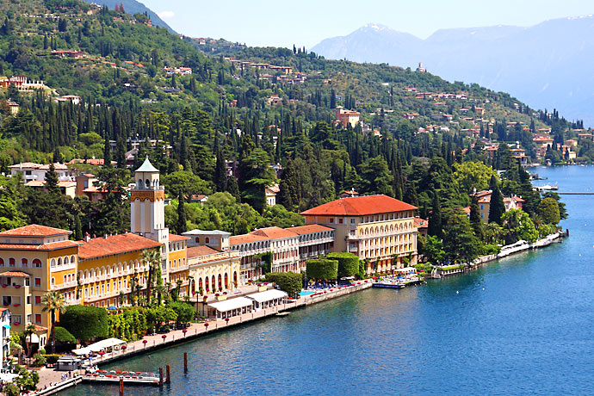

Grand Hotel Gardone in Gardone Riviera Photo ©Brightwater Holidays

Dinner will be served at the hotel this evening.

**Friday 16 September 2016**

Our garden visits today will first embrace the excesses of poetic eccentricity at **Il Vittoriale degli Italiani,** in Gardone Riviera. This is the extravagant citadel built for the Italian poet Gabriele d’Annunzio in 1922, conceived as a fantastical mausoleum for his artistic and heroic adventures with the help of the architect Giancarlo Maroni. The house is full of art objects, ceramics, carpets and strange memorabilia. Nature and Art are united as a “two-faced god” in the curious perspectives of the garden. Here is a geometrical terrace, there a sensual rose garden, over there an amphitheatre, and still more with palms, acanthus, oleanders, myrtle, rhododendrons, and cypresses. Pomegranates, D’Annunzio’s symbol of life, are everywhere. His military experience is on display in his own museum. Epic rocks fallen from the mountains during the First World War can be found on the grounds, as well as the prow of the battleship Puglia set in the garden and reaching towards the lake.

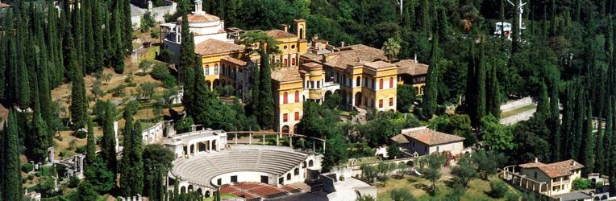

Il Vittoriale degli Italiani in Gardone Riviera Photo ©Brightwater Holidays

After time out for lunch (not included) in the charming village of Gardone Riviera, our afternoon visit will be to the **Andrè Heller Botanical Garden**, where more than 3,000 species from all over the world can be found in a plot of about 10,000 square metres. Naturalness and spontaneity of the landscape are paramount here but the garden is also embellished by entertaining sculptures by modern artists such as Keith Haring and Roy Lichtenstein and Indian pieces. Originally planted in 1912-14 by Dr. Arturo Hruska, dentist to the Tsar, the Savoy Royal family, and other famous personalities, the Austrian poet-artist André Heller has been the property’s custodian since 1989.

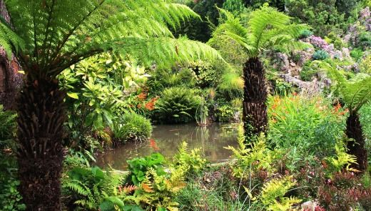

André Heller Botanical Garden Photo ©Brightwater Holidays

**Saturday 17 September 2016**

Today we will spend a delightful morning sailing to and exploring **Isola del Garda**, the biggest island on Lake Garda that was home, in the past, to many saints like St Francis and poets, including, as the story goes, Dante Alighieri. The early 20th-century **Villa Borghese Cavazza** is in Venetian neo-Gothic style and is situated so as to dominate the terraces and formal gardens that stretch down to the lake, offering a range of intact native and exotic planting. Today the villa is looked after by Count Camillo Cavazza’s wife Charlotte Chetwynd Talbot and their seven children.

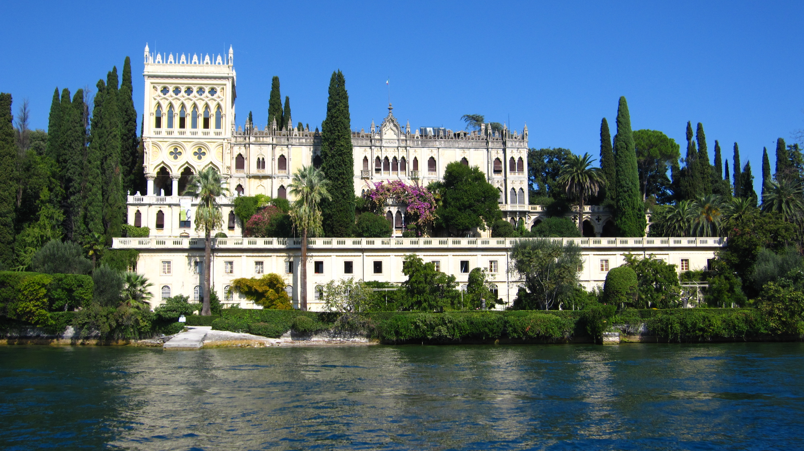

Borghese Cavazza, Isola del Garda Photo ©Brightwater Holidays

In the afternoon we visit the little village of **Gargnano** with its lakeside restaurants and ancient church, making a stop to see one of the recovered lemon-houses described so well in D.H. Lawrence’s book *Twilight in Italy* after his one-year stay here with Frieda in 1913.

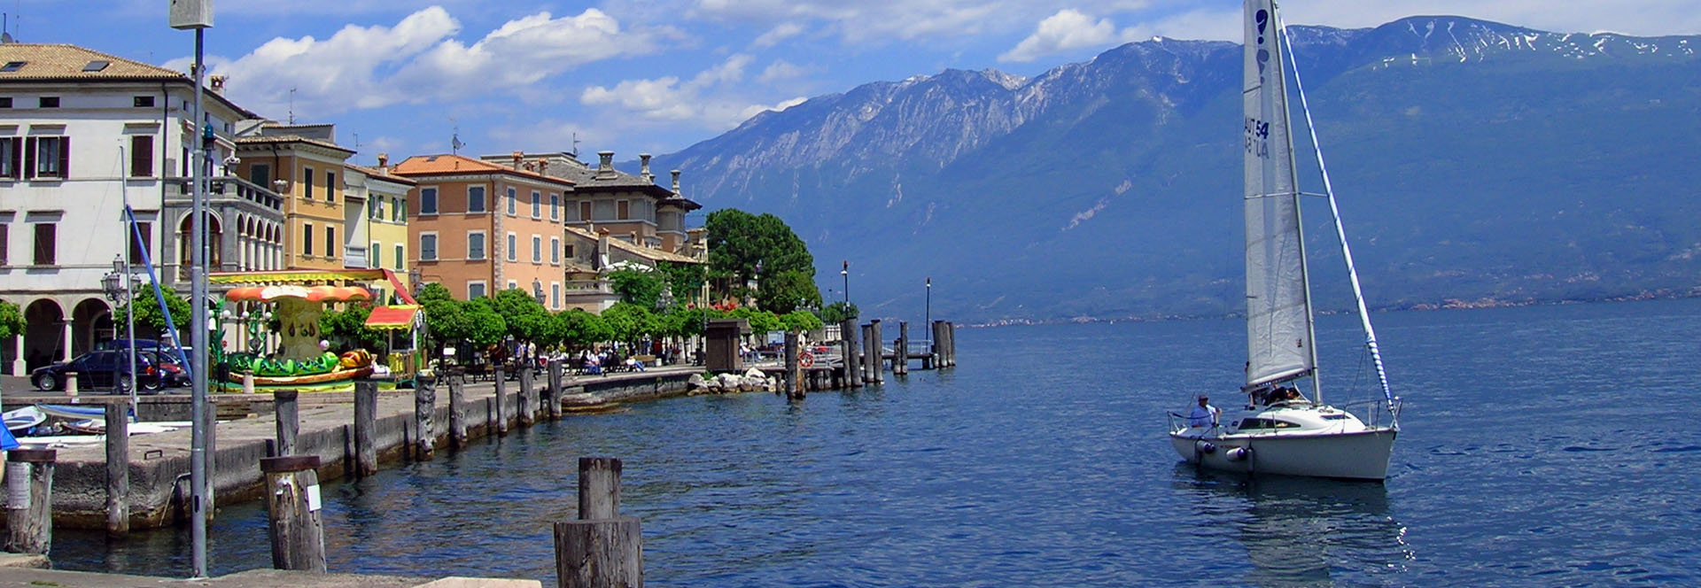

Gargnano, Isola del Garda Photo ©Brightwater Holidays

Dinner will be served in the hotel.

**Sunday 18 September 2016**

This morning we will check out of the hotel and transfer to Stresa. Before we leave the Garda area, we stop in **Desenzano** to see the well-preserved floor mosaics of the ancient Roman villa there and stop at **Erbusco** to visit a vineyard in the Franciacorta morainic basin.

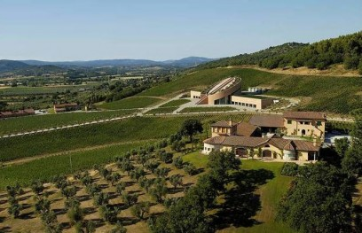

Erbusco vineyard Photo ©Brightwater Holidays

We will transfer to the Hotel la Palma in Stresa, where dinner will be served in the evening.

**Monday 19 September 2016**

This morning we take a short drive to visit the marvellous **Giardini Botanici Villa Taranto** at a truly leisurely pace. These botanical gardens were laid out over a period of many years from 1931-40 by the Scotsman Neil McEachern, whose father had founded a great shipping line to Australia. McEachern created one of the greatest gardens of Europe, a “living encyclopaedia of horticulture”, enriched with species from all over the world. Villa Taranto houses 20,000 plants of botanic value and is full of colour from the blooming of spring-time to the bold splashes of colour in the dahlia labyrinth and the autumnal shades of the acers and other handsome trees.

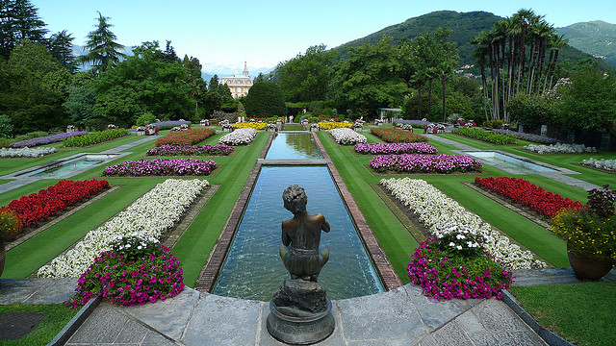

Giardini Botanici Villa Taranto

Photo ©Brightwater Holidays

**Monday 19 September 2016 (continued)**

After a chance for lunch (not included), we will spend the afternoon in the picturesque lakeside village of **Orta San Giulio** on the lesser-known **Lake Orta**. The frescoes and ancient carved stone pulpit in the 12th-century island Basilica church are not to be missed. The church and compound at **Sacro Monte**, the steep hillside above the town in a beautiful mixed woodland area, is a UNESCO World Heritage Site, known for its rare artistic, cultural, and natural beauty with chapels full of life-sized terracotta statues and paintings that tell the story of St Francis of Assisi.

Dinner will be served in the evening.

**Tuesday 20 September 2016**

The morning is at leisure to enjoy Stresa and the hotel.

Our afternoon journey takes us away from Lake Maggiore to the **Villa Cicogna Mozzoni** at Bisuschio in the foothills between lakes Maggiore and Lugano. Here, the owner Iacopo Cicogna Mozzoni is trying to meet all the challenges of preserving the historic family home, precious terraced garden, and water stairway despite the passage of time and the pressures of the 21st century. Built originally as a hunting lodge, the property reveals the family’s rise in fortunes and contact with Rome, leaving us with a fine and rare example of a Renaissance villa, complete with frescoes, unusual perspective painting, and optical effects.

Dinner will be served in the evening.

**Wednesday 21 September 2016**

On our final magical day, we enjoy a truly leisurely pace to visit the “botanical treasure islands” of **Isola Bella** and **Isola Madre**, set in the waters just off the shoreline of Borromean Bay. Starting about 10am, our private motor boat will take us to the baroque extravagance of **Palazzo Borromeo** (1632) on Isola Bella with its monumental, formal Italianate gardens seemingly floating in the waters of the lake like a galleon. After free time for lunch, we continue to Isola Madre, “earthly paradise”, with its ancient house and fine botanical garden. Curator Gianfranco Giustina, justly awarded the RHS Veitch Medal in 2014 for his contribution to the world of horticultural achievement, continues a long tradition of acclimatization of rare plants, including the Proteus.

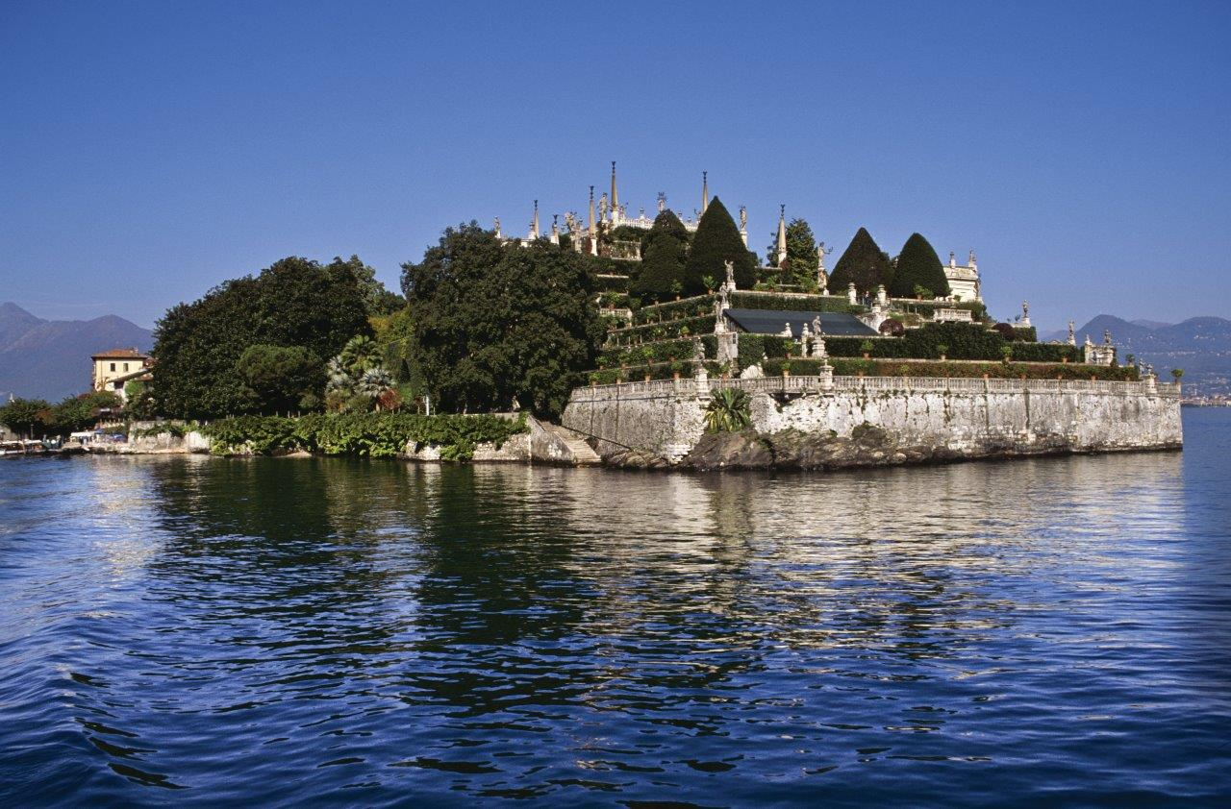

Palazzo Borromeo, Isola Bella, Lake Maggiore Photo ©Brightwater Holidays

Finally, on our last evening together, we will go to Isola Pescatori for dinner on our own at restaurants of our choice.

**Thursday 22 September 2016**

Following breakfast, we will check out of the hotel and return by bus to Milan airport for our flight home (under own arrangement).

**Included in the price**

* 3 nights’ accommodation in the Hotel Barchetta Excelsior, Como (or similar) – 2 nights’ dinner, bed and breakfast and 1 night bed and breakfast. Welcome drink on arrival
* 3 nights’ accommodation in the Grand Hotel Gardone, Gardone Riviera (or similar) – 2 nights’ dinner, bed and breakfast, and 1 night bed and breakfast
* 4 nights’ accommodation in the Hotel La Palma, Stresa (or similar) – 3 nights’ dinner, bed and breakfast, and 1 night bed and breakfast
* Comfortable transportation by coach and water taxi throughout
* All entrance fees to gardens and boat transfers as detailed in the itinerary
* Services of Kate Williamson as Tour Manager throughout (information continues on next page)

**Not included (per person)**

* All lunches
* Single room supplement £475
* Farewell dinner on Isola Pescatori
* Insurance
* Personal services from hotel staff & telephone calls